Case1- England-Suffolk-High Lodge, Mildenhall-End Scraper, 352,000-130,000 BP

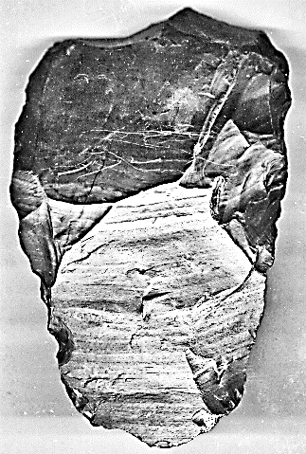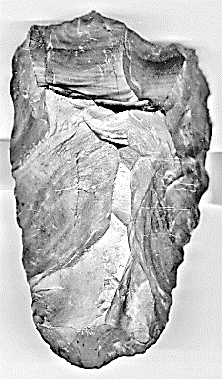 

Fig. 2. Mildenhall end scraper, dorsal view, from Roe 239, no 11.

Fig. 1. Mildenhall end scraper, ventral (left) and dorsal view (right).

**Formal Label:** England-Suffolk-High Lodge, Mildenhall End Scraper-352,000-130,000 BP

**Accession Number: A12**

**LC Classification:** GN772.22.G7

**Date or Time Horizon:** 350,000-200,000 BP

**Geographical Area:** Mildenhall Area, Suffolk.

**Map:** from Roe 1981: 95.

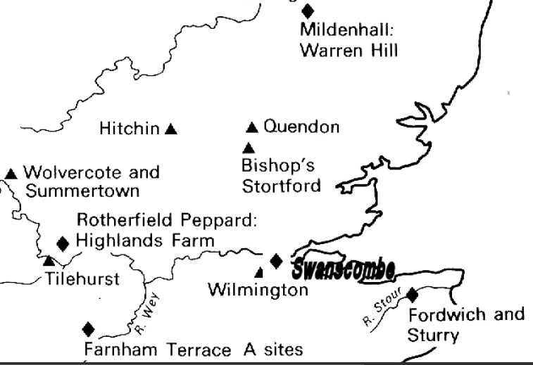

**Figure 3. Mildenhall, Kent (top), and other Early Acheulian sites (diamonds);**

**also Late Acheulian sites (triangles).**

**Cultural Affiliation:** Acheulian, Homo Heidelbergensis

**Medium:** Flint

**Dimensions: H 12.5 cm; W 8.7 cm.  
Weight: ?**

**Provenance: Old English Collection from 1920’s**

**Condition:** This rare end scraper is in museum grade condition with the ‘classic flake industry of High Lodge’ detail and ancient patination.

**Discussion:** Lake-margin sediments of “Wolstonian Interstadial age yielded two flake industries, a lower rather crude one and an upper one with elegant and finely made flake tools (the ‘classic flake industry of High Lodge’)” (Roe 1981: 238). The Wolstonian Interstadial age is equivalent to Marine Isotope stages 6 through 10 (McMillan 2005; Gibbard, Boreham, Cohen, Moscariello 2007) with a duration of 352,000 BP to 130,000 BP (Lisiecki 2005, Lisiecki and Raymo 2005).

This large end-scraper has the high quality of retouch of the ‘classic flake industry of High Lodge’ (352,000 BP to 130,000 BP) along the lateral and distal edges with a steeply pitched dorsal ridge and an expertly faceted ventral platform. Also an expertly flaked hafting groove at the proximal end makes this a unique tool (see Roe 1981: 239, no. 11).

**References:**

Gibbard, P.L.; Boreham, S.; Cohen, K.M.; Moscariello, A.2007.["Global chronostratigraphical correlation table for the last 2.7 million years"](http://www.quaternary.stratigraphy.org.uk/correlation/POSTERSTRAT_v2007b_small.jpg) (JPG 844 kb). Cambridge UK: Subcommission on Quaternary Stratigraphy, Department of Geography, University of Cambridge.

[Lisiecki, L.E.](https://en.wikipedia.org/wiki/Lisiecki,_L.E.), 2005, “[Ages of MIS boundaries.](http://www.lorraine-lisiecki.com/LR04_MISboundaries.txt) [LR04 Benthic Stack](http://www.lorraine-lisiecki.com/stack.html).” Boston, MA: Boston University.

[Lisiecki, L.E.](https://en.wikipedia.org/wiki/Lorraine_Lisiecki); [Raymo, M.E.](https://en.wikipedia.org/wiki/Maureen_Raymo) 2005. ["A Pliocene-Pleistocene stack of 57 globally distributed benthic d18O records,"](http://www.lorraine-lisiecki.com/LisieckiRaymo2005.pdf) (PDF). *Paleoceanography,* **20**:1003*.*

McMillan, A.A. 2005*.* "A provisional Quaternary and Neogene lithostratigraphic framework Great Britain," *Netherland Journal of Geosciences,* 84 (2): 87–107.

Roe, Derek. 1981.*The lower and middle Paleolithic periods in Britain*. Series: Archaeology of Britain, Barry Cunliffe, ed. London, Boston and Henley: Routledge and Keegan Paul.